

Software requirement specification document for project Banking System

Ahmed Mohamed, Ali Mohamed, Soliman Salama, Mohamed Ibrahim

Supervised by: Dr. Ayman Ezzat

May 16, 2020

# Introduction

In our system we aim to find out a creative solution for bank system routine. This system will replace the usual paper-based system for banking operations for a modern technology that is easy to use, and this system will make the customer control his bank account via smart phones and laptops. It allows the Client to deposit funds and use our checking accounts and debit cards to pay his bills or make purchases. Customer can easily pay their bills and save the money and time wasted when they need to pay bills through convert the service of payment to online service.

* 1. **Purpose of this document**

The purpose of this project to give solutions to the most problems in traditional Banks. The functionalities of our system will facilitate the Customer’s banking dealings. The intended audience are Tellers and Managers.

## Scope of this document

The scope of this document will be on Customers, Tellers and Admins. This system is responsible for operating a payment system, providing loans, taking deposits, and helping with investments. We have used Jira software to arrange and manage our requirements in our system.

## Overview

In this system there are 3 Different types of users: Admin, Teller and Customer. Our system will facilitate for customers to make their banking transactions in easy way to use.

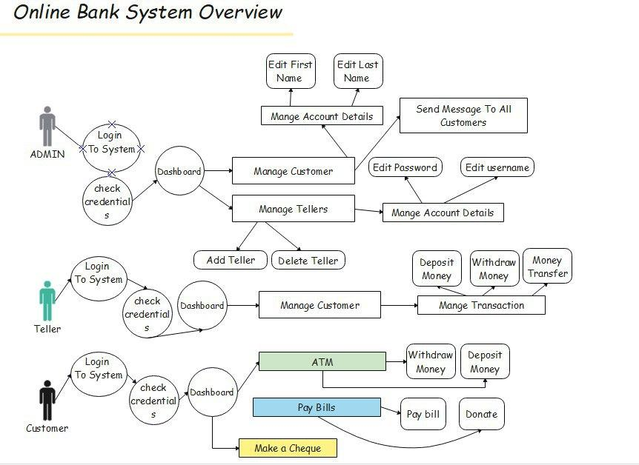

## Business Context

Our project is tending to solve two main problems, it will solve the data redundancy and save time and money and it will also solve global trade problems by making most companies around the world conduct their transactions easily and transfer their money from country to country to easily. it will also replace the usual paper-based system for banking operations .

# 2 General Description

## 2.1 Product Functions

. Functions of Our Online Banking System:

* Admin Dashboard
* Easy Clients registration
* Customer Dashboard
* Teller Dashboard
* Admin Login pages are hidden from customers for security purposes.
* Teller mange the Customer’s transfer, withdraw and Deposit
* Print the invoice Voucher for deposit and withdrawal from the ATM

## Similar System Information

Digital Web Plus Online Banking System: This is an Online Banking System source code developed in PHP, HTML, JavaScript, and MySQL database. This site has a beautiful and simple design but it has a limited number of users and they are the client and the admin and It doesn't have a lot of features.

|  |  |  |  |
| --- | --- | --- | --- |
|  | **Digital Web** | **B.A.M** | **Our**  **System** |
| Design GUI | ✓ | ✗ | ✓ |
| User Experience | ✗ | ✓ | ✓ |
| Several Features | ✗ | ✓ | ✓ |
| Different Users | ✗ | ✗ | ✓ |
| Web-Based | ✓ | ✓ | ✗ |

Bank account management system by Md. Jasim Uddin from City university: Their primary aim to develop a project for solving financial application of a customer in banking environment by providing various ways to perform banking tasks. Also, to enable the user’s facilities to have additional functionalities and to provide secure and efficient net banking which are not provided under a conventional banking project. This system contains many features and functions that the user can use easily and provide more security for the user but it has a non-developed design which make them look like an old system.

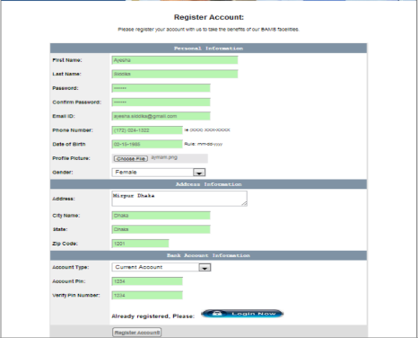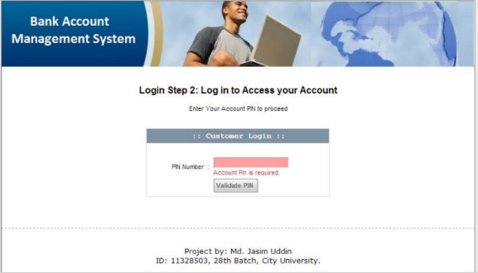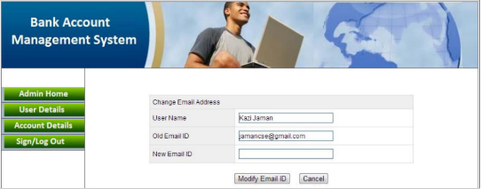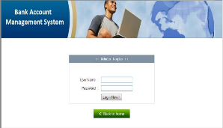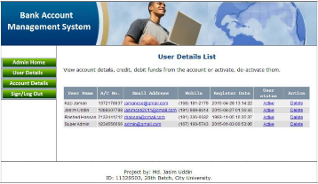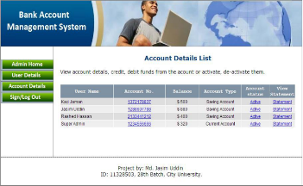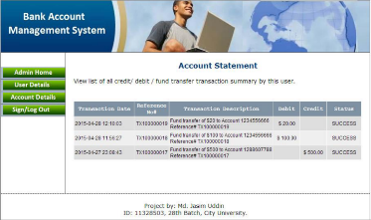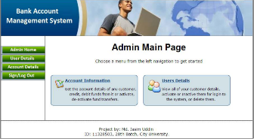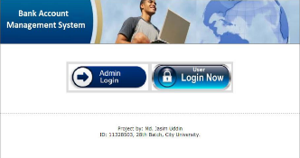

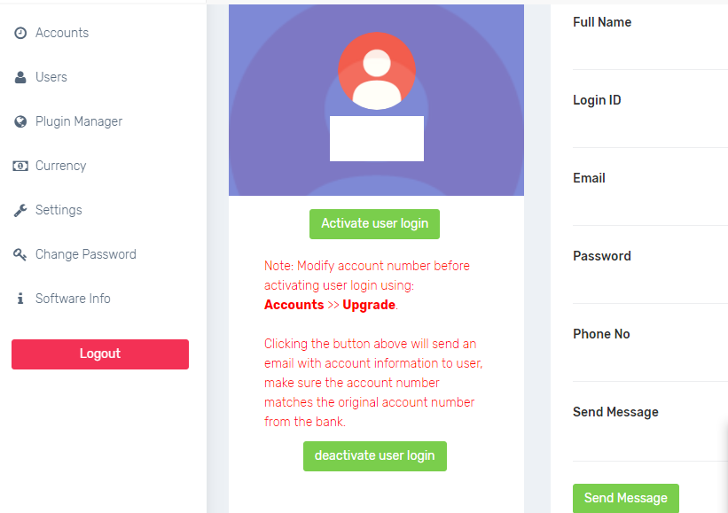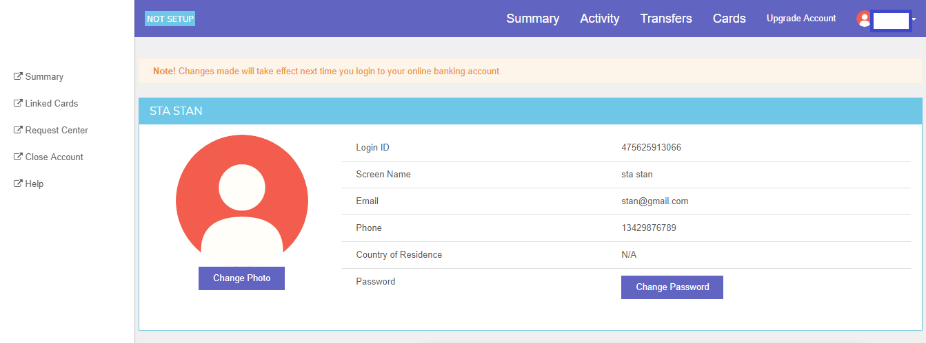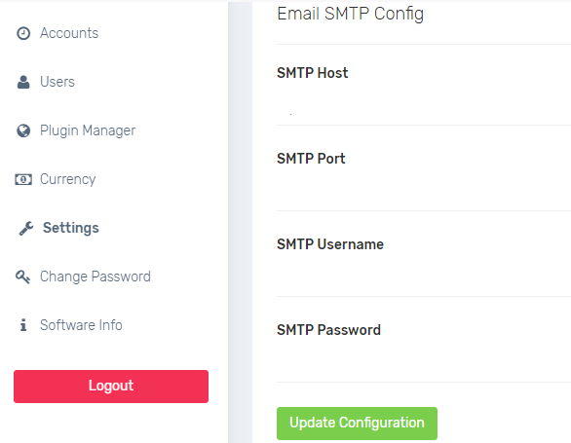

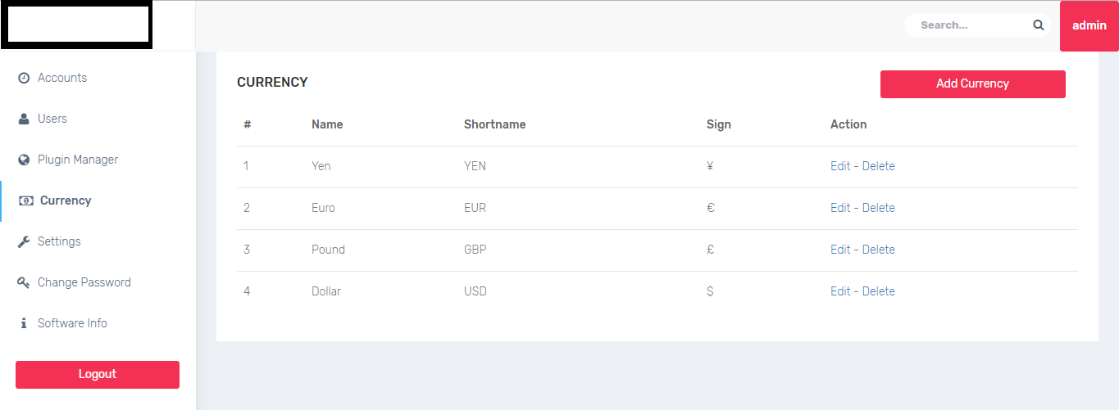



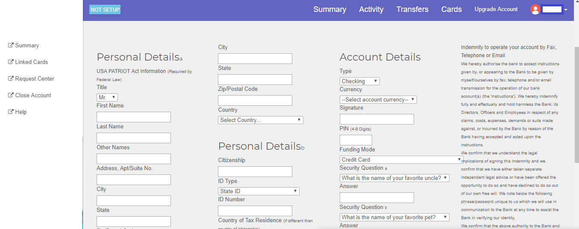

## User Characteristics

People who will use our system must be proficient in using computers and smartphones. They should know English to be able to deal with the system

## User Problem Statement

The user 's problem it was in the time wasted, data redundancy and failure Transactions.

## User Objectives

The user wants to have his own control panel and also wants to control his account using a software system and dispense paper dealings

## General Constraints

This system works on computers and all types of processors are allowed to run this system

# Functional Requirements

|  |  |
| --- | --- |
| Function code | 1 |
| Function Name | bunifuThinButton29_Click//Login |
| Description | This function will loop on all data base tables and it will check if the user state =0 then it will login as admin if the user state =1 then it will login as teller if the user state =2 then it will login as customer |
| Priority | 10/10 |
| Input | Enter Username and enter Password |
| Output | Admin Dashboard or Teller Dashboard or Customer Dashboard |
| Critically | high |
| Risks | Database may be failure |
| Dependencies with other requirements | 2)Form1_Load() // for select the functions |
| Pre-Condition | Not logged in |
| Post-Condition | Logged in |

|  |  |
| --- | --- |
| Function code | 3 |
| Function Name | withdraw_click () |
| Description | This function will loop on Account data base rows [dt.Rows] and it will search on the Customer Account number if it located then the Account balance will reduce in his account and it will be updated in the data base. |
| Priority | 9/10 |
| Input | Variable real_account will be become each row value until reach the specified Account number |
| Output | the BLAcc will becomes the new value balance and it will be updated in the data base |
| Critically | high |
| Risks | Database may be failure |
| Dependencies with other requirements | 1)bunifuThinButton29_Click() // for Login  2)Form1_Load() // for select the functions |
| Pre-Condition | Account balance unchanged remains the same value |
| Post-Condition | Account Balance reduced |

|  |  |
| --- | --- |
| Function code | 4 |
| Function Name | deposite_click () |
| Description | This function will loop on Account data base rows [dt.Rows] and it will search on the Customer Account number if it located then the Account balance will be the value inserted in the text box and it will be updated in the data base. |
| Priority | 9/10 |
| Input | Variable real_account will be become each row value until reach the specified Account number |
| Output | the BLAcc will becomes the new value balance and it will be updated in the data base |
| Critically | high |
| Risks | Database may be failure |
| Dependencies with other requirements | 1)bunifuThinButton29_Click() // for Login  2)Form1_Load() // for select the functions |
| Pre-Condition | Account balance unchanged remains the same value |
| Post-Condition | Account Balance increased by the value inserted in text box |

|  |  |
| --- | --- |
| Function code | 5 |
| Function Name | bunifuThinButton21_Click () // for Pay bill |
| Description | If the customer presses the Bill radio button then he will Select the Organization. This function will loop on Account data base rows [dt.Rows] . the customer will enter the amount there will be a condition (new balance-amount>=0) if this condition is true the Account balance will be the value inserted in the text box and it will be updated in the data base. |
| Priority | 9/10 |
| Input | Variable new balance will be become the value inserted in textbox |
| Output | the BLAcc will becomes the new balance and it will be updated in the data base |
| Critically | high |
| Risks | Database may be failure |
| Dependencies with other requirements | 1)bunifuThinButton29_Click() // for Login  2)Form1_Load() // for select the functions |
| Pre-Condition | Account balance unchanged remains the same value |
| Post-Condition | Account Balance decreased by the value inserted in text box |

|  |  |
| --- | --- |
| Function code | 6 |
| Function Name | bunifuThinButton21_Click () // for donate |
| Description | If the customer presses the Donate radio button. then he will Select the charity. This function will loop on Account data base rows [dt.Rows] . the customer will enter Amount there will be a condition (new balance-amount>=0) if this condition is true the Account balance will be the value inserted in the text box and it will be updated in the data base. |
| Priority | 9/10 |
| Input | Variable new balance will be become the value inserted in textbox |
| Output | the BLAcc will becomes the new balance and it will be updated in the data base |
| Critically | high |
| Risks | Database may be failure |
| Dependencies with other requirements | 1)bunifuThinButton29_Click() // for Login  2)Form1_Load() // for select the functions |
| Pre-Condition | Account balance unchanged remains the same value |
| Post-Condition | Account Balance decreased by the value inserted in text box |

|  |  |
| --- | --- |
| Function code | 7 |
| Function Name | makecBtn_Click () // for make cheque |
| Description | This function will loop on Account data base rows [dt.Rows] . the customer will enter the Customer Account number if it located the Account balance will be the value inserted in the text box and it will be updated in the data base. And the voucher cheque is ready for printing |
| Priority | 8/10 |
| Input | Variable new balance will be become the value inserted in textbox |
| Output | the BLAcc will becomes the new balance and it will be updated in the data base |
| Critically | high |
| Risks | Database may be failure |
| Dependencies with other requirements | 1)bunifuThinButton29_Click() // for Login  2)Form1_Load() // for select the functions |
| Pre-Condition | Account balance unchanged remains the same value |
| Post-Condition | Account Balance decreased by the value inserted in text box  And the cheque is ready for printing |

|  |  |
| --- | --- |
| Function code | 8 |
| Function Name | Transfer () |
| Description | The customer will enter his account number and the receiver account number and the amount to be transfer This function will loop on Account data base rows [dt.Rows] then the Receiver Account balance will be the value inserted in the text box and it will be updated in the data base. |
| Priority | 9/10 |
| Input | Variable new balance will be become the value inserted in textbox |
| Output | the BLAcc will becomes the new value balance and it will be updated in the data base |
| Critically | high |
| Risks | Database may be failure |
| Dependencies with other requirements | 1)bunifuThinButton29_Click() // for Login  2)Form1_Load() // for select the functions |
| Pre-Condition | Sender Account balance unchanged remains the same value |
| Post-Condition | Sender Account Balance decreased by the value inserted in text box  Receiver Account Balance increased by the value inserted in text box |

# 4 Interface Requirements

## 4.1 User Interfaces

**4.1.1 GUI**

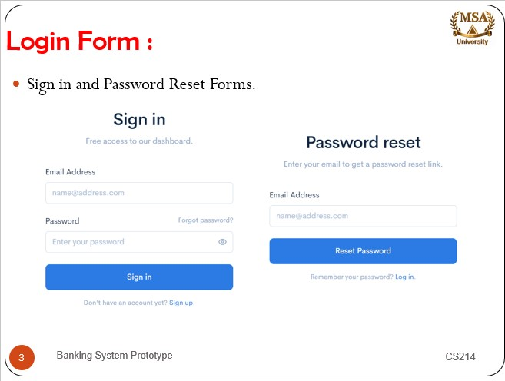

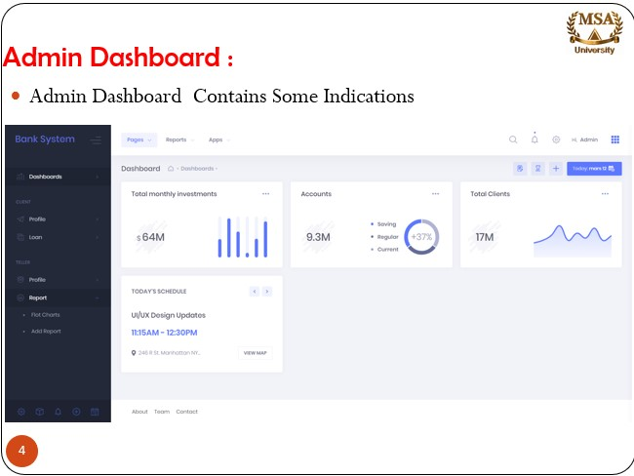

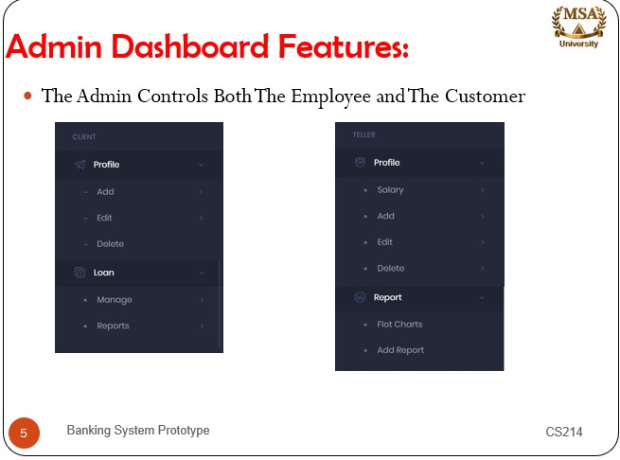

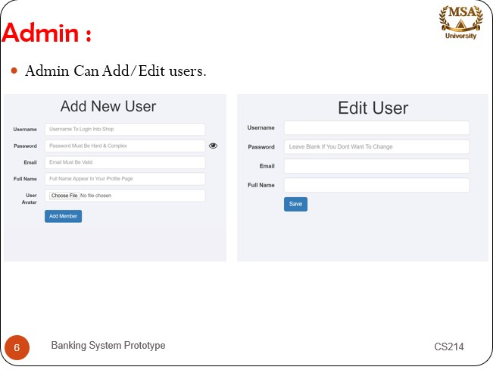

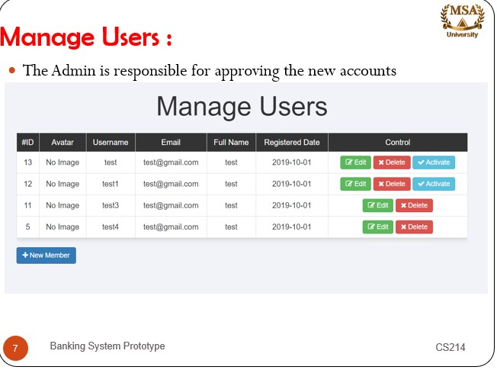

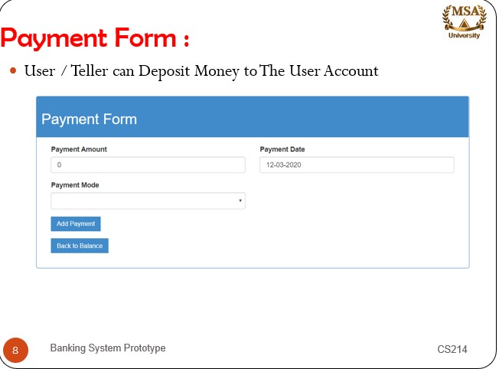

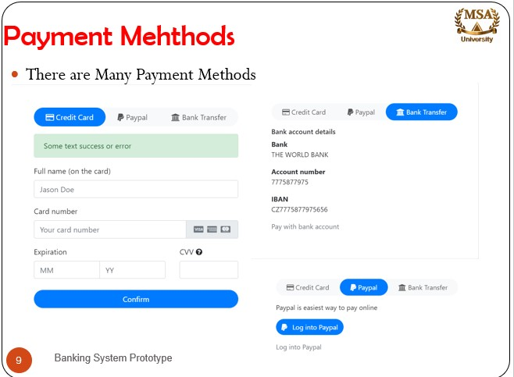

**4.1.2 CLI**

Not Available.

**4.1.3 API**

We use ready-made tools Bunfi tool and Metro Framework

**4.4 Software Interfaces**

We use the visual studio to run the C# language and we use the sql server as a database.

# 6 Design Constraints

**6.1 Standards Compliance**

Not Available.

**6.2 Hardware Limitations**

Any Windows 10 Running Pc.

# 7 Other non-functional attributes

**7.1 Dependability:** FUNCTIONS (1) login ( ) and (2) load( ) are on all functions requirements

**7.2 Portability**

This System will run on windows. this need to work with C# and it tested by windows 10

**7.3 Extensibility**

Our system use sql server so we can insert an unlimited number of users

**7.4 Re-usability**

In DAL class it contains read and write from database functions and we use it to insert and update

**7.5 Application Affinity/Compatibility**

Download cheque voucher and deposit voucher

# 8 Preliminary Object-Oriented Domain Analysis

## 8.1 Inheritance Relationships

This section should contain a set of graphs that illustrate the primary inheritance hierarchy (is-kind-of) for the system. For example:

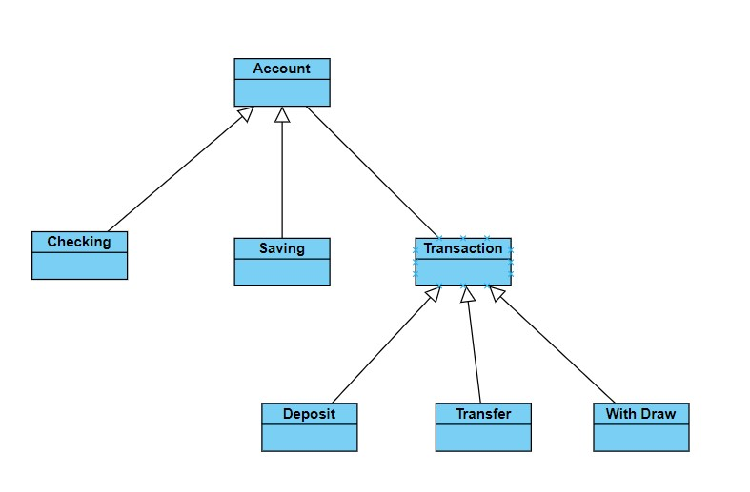 Figure 1: Inheritance Relations

## 8.2 Class descriptions

This section presents a more detailed description of each class this information is in CRC Cards

**8.2.2 List of Superclasses:**

1)Account

2)Transaction

3)Bank Employee

**8.2.3 List of Subclasses:**

1.1) Checking

1.2) Saving

2.1) Deposit

2.2) transfer

2.3) withdraw

3.1) ATM operator

3.2) Teller

3.3) Manager

**8.2.4 Operations**

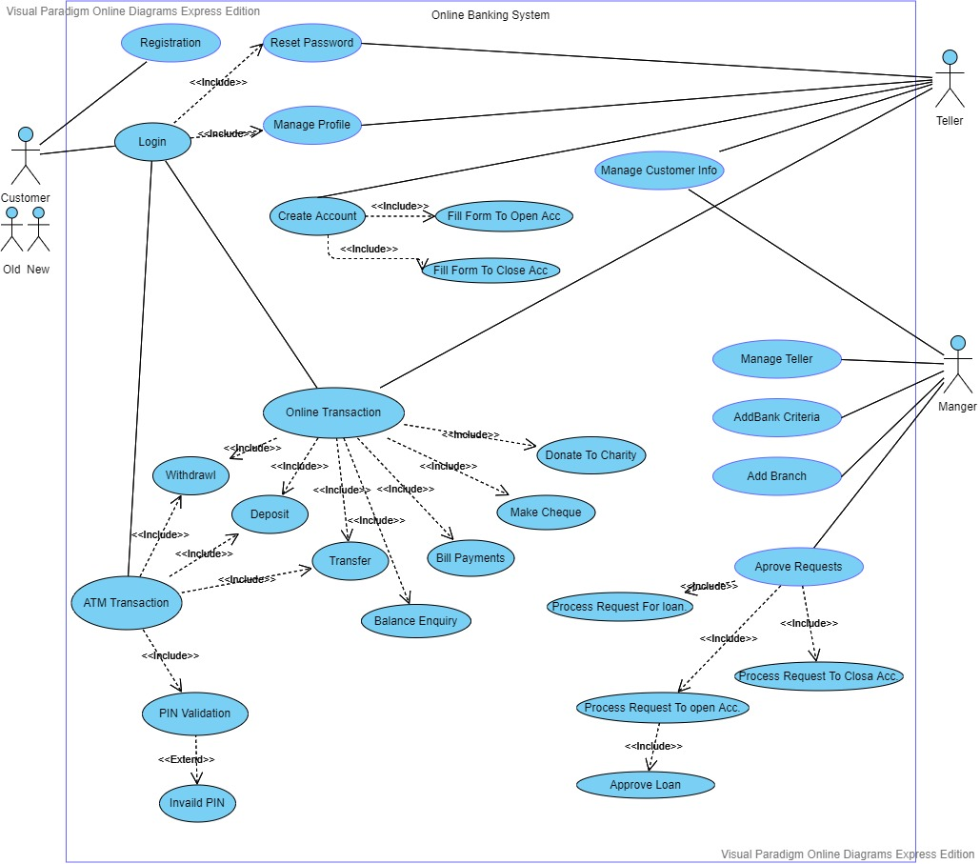

# A close up of text on a whiteboard Description automatically generated12 Appendices

Specifies other useful information for understanding the requirements. All SRS documents should include at least the following two appendices:

**12.2 Collected material**

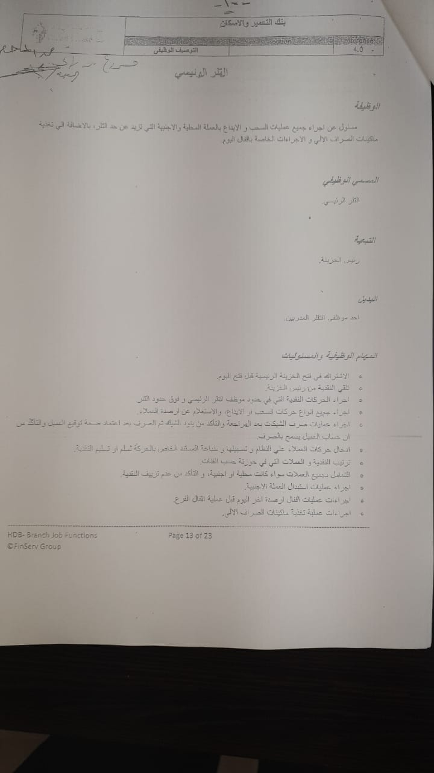

**13 References**

# References

1. Anna malai, Saravanan. (2015). system analysis and design - internet banking. 10.13140/RG.2.1.4223.6000.
2. Uddin, Md. Jasim & Nuruzzaman, Md. (2015). Bank Account Management System. 10.13140/RG.2.1.4335.9120.